Project documentation

Rhythmic tunes: your melodic companion

1.INTRODUCTION

PROJECT TITLE: RHYTHMIC TUNES: YOUR MELODIC COMPANION

TEAM ID: NM2025TMID37084

TEAM LEADER: BHUVANESHWARI R

MAIL ID: [bhuvaneshwari06.r@gmail.com](mailto:bhuvaneshwari06.r@gmail.com)

TEAM MEMBER 1: DARATHI SUJANA B

MAIL ID: [darathisujana@gmail.com](mailto:darathisujana@gmail.com)

TEAM MEMBER 2: KAMALYA SRI A

MAIL ID: [kamalyaarumugam@gmail.com](mailto:kamalyaarumugam@gmail.com)

TEAM MEMBER 3: LEELAVATHY A

MAIL ID: leelavathyanbu18@gmail.com

**PROJECT OVERVIEW**

**Rhythmic Tune** is a responsive web-based music streaming platform that allows users to discover, play, and create playlists of their favorite songs. This documentation covers the frontend development structure, tools, technologies, and guidelines used in building the user interface of Rhythmic Tune.

PROJECT STRUCTURE

rhythmic-tune-frontend/

│

├── public/ # Static files (index.html, favicon, etc.)

├── src/

│ ├── assets/ # Images, icons, fonts

│ ├── components/ # Reusable React components (Navbar, Player, etc.)

│ ├── pages/ # Route-based views (Home, Search, Library, etc.)

│ ├── services/ # API service handlers

│ ├── hooks/ # Custom React hooks

│ ├── context/ # React Contexts for global state (auth, theme)

│ ├── styles/ # Global styles (CSS/SCSS or styled-components)

│ ├── App.js # Main app component

│ ├── index.js # Entry point

│ └── routes.js # App route configuration

├── .env # Environment variables

├── package.json

└── README.md

USER INTERFACE

The **User Interface (UI)** of **Rhythmic Tune** is designed with a focus on **usability**, **performance**, and **visual appeal**. The platform serves multiple user roles — **listeners**, **freelance music creators**, and **admins** — each with distinct interfaces and features. Below is a breakdown of the main UI components.

THE TECHNOLOGY WE USED,

* HTML
* CSS
* JAVASCRIPT

SOURCE CODE

<!doctype html>

<html lang="en">

<head>

<meta charset="UTF-8" />

<link rel="icon" type="image/svg+xml" href="/vite.svg" />

<meta name="viewport" content="width=device-width, initial-scale=1.0" />

<link href="https://cdn.jsdelivr.net/npm/tailwindcss@2.2.16/dist/tailwind.min.css" rel="stylesheet">

<title>Music-Player</title>

</head>

<body>

<div id="root"></div>

<script type="module" src="/src/main.jsx"></script>

</body>

</html>

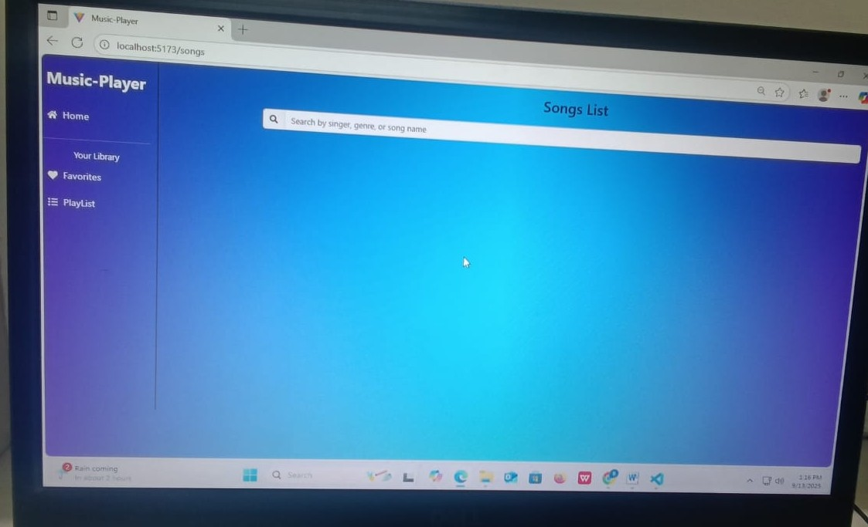OUTPUT SCREENSHOTCONCLUSION

**Rhythmic Tune** is a simple, static web page designed to showcase rhythmic music content with a clean and user-friendly interface. Built using basic HTML and CSS, it features sections like a header, featured tunes, about, contact form, and footer. The project requires no backend and can be easily viewed by opening the HTML file in any modern browser. It serves as a lightweight, easy-to-customize frontend for music-related websites or portfolios.

DEMO LINK:

<https://drive.google.com/drive/folders/1O7Eqp-ufTyv_iDaShHKf38oAZREkXb28>

THANK YOU